1.: Write a simple "Hello World" program in two different programming languages of your choice. Compare the structure and syntax.

Ans.

Hello world program in c

#include<stdio.h>

Main(){

Printf(“hello world”);

}

Hello world program in python

Print(“hello world’);

2. Research and create a diagram of how data is transmitted from a client to a server over the internet.

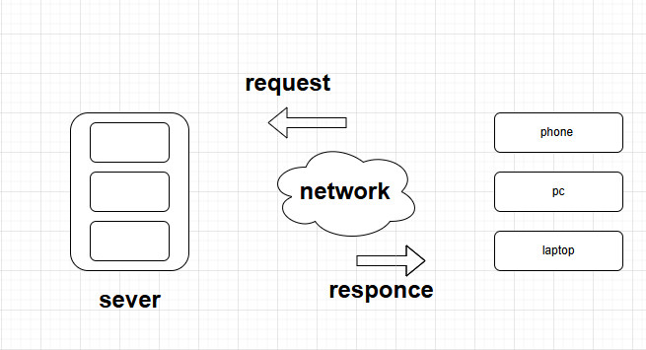

3. : Design a simple HTTP client-server communication in any language

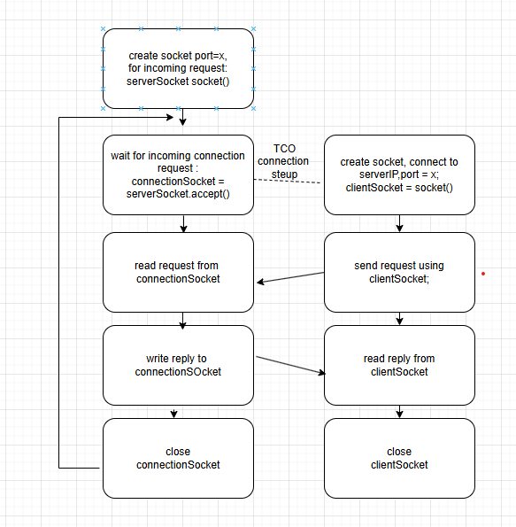

4. : Research different types of internet connections (e.g., broadband, fiber, satellite) and list their pros and cons.

Ans.

**1. Dial-Up Connection**

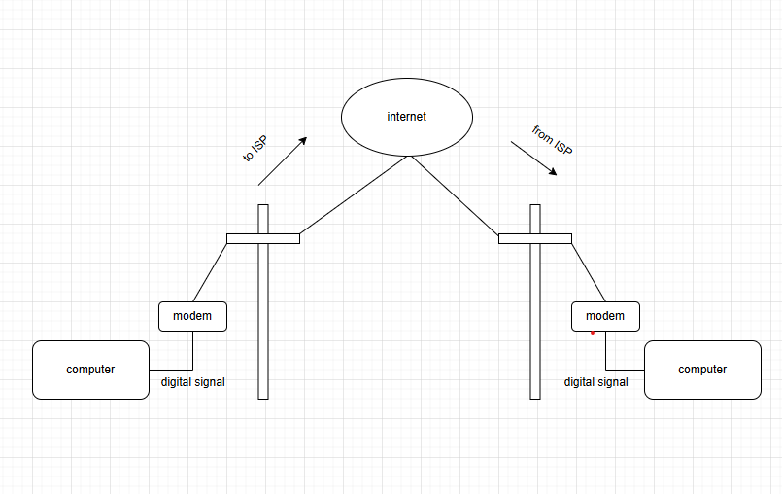

2.Broadband connection

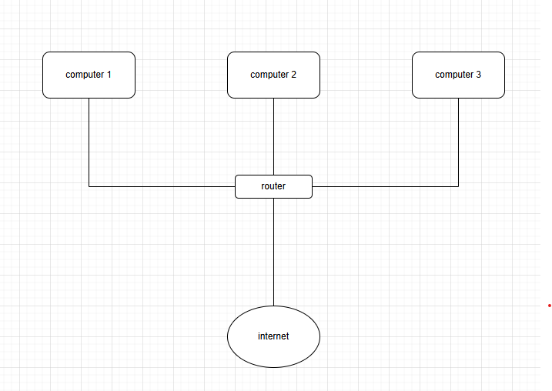

3. **DSL (Digital Subscriber Line)**

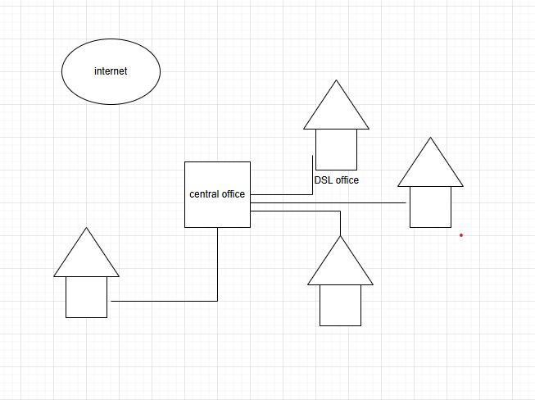

4. **Cable**

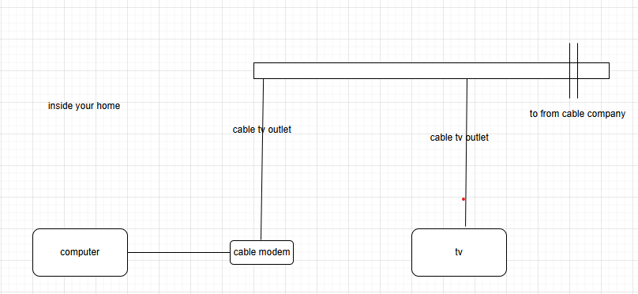

5. **Satellite Connection**

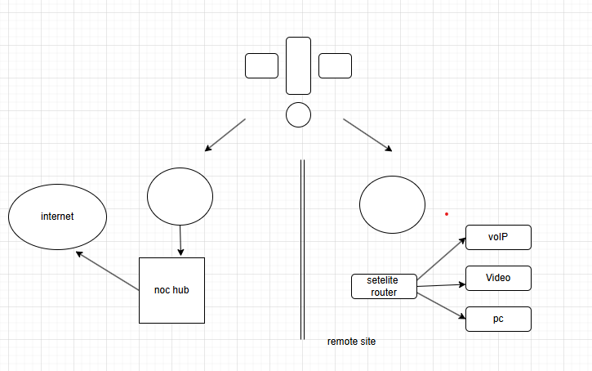

**6. Wireless Connection**

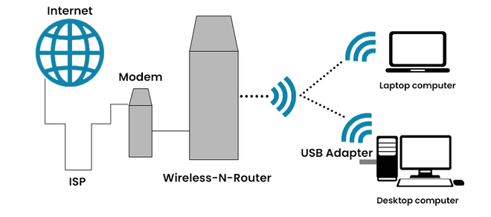

**7. Cellular**

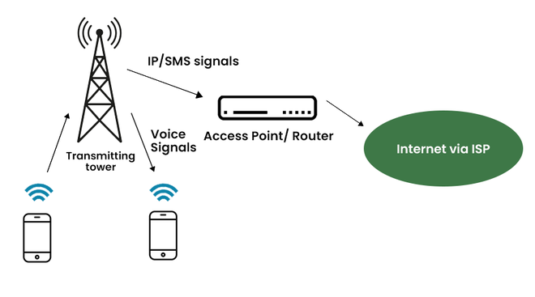

3. : Identify and explain three common application security vulnerabilities. Suggest possible solutions.

1.Injection attack

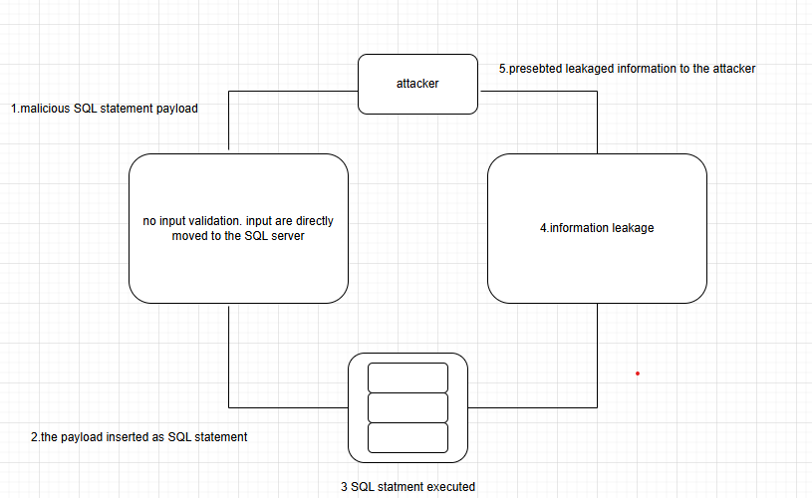

2.broken authentication

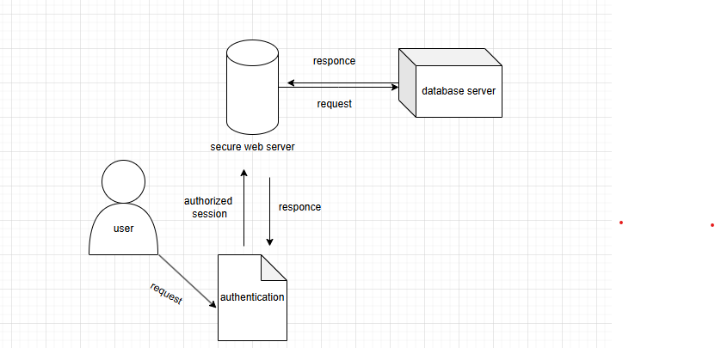

3. Sensitive data exposure

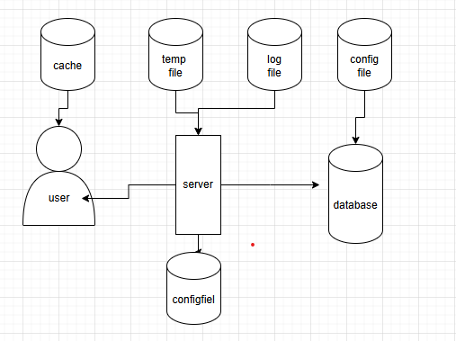

5. Identify and classify 5 applications you use daily as either system software or application software.

Ans.

1. **Windows Operating System (OS)**
2. **Antivirus Software**
3. **Google Chrome (Web Browser)**
4. **Microsoft Word (Word Processor)**
5. **Microsoft Outlook (Email Client)**

6. Design a basic three-tier software architecture diagram for a web application.

Ans.

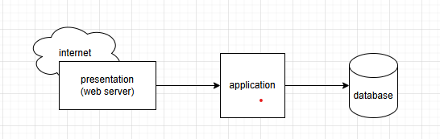

7. Create a case study on the functionality of the presentation, business logic, and data access layers of a given software system.

Ans.

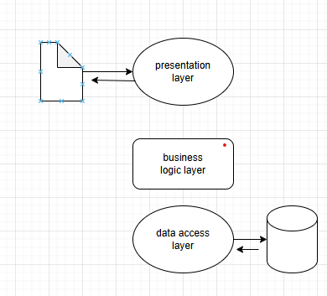

8. : Explore different types of software environments (development, testing, production). Set up a basic environment in a virtual machine.

Ans.

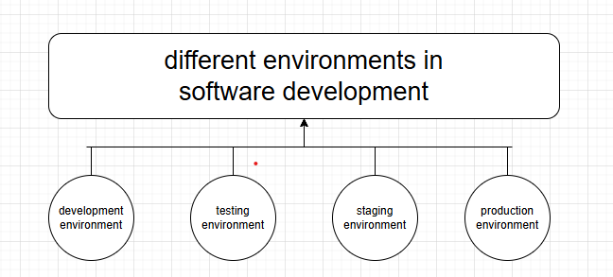

9. : Write a requirementspecification for a simple library management system.

Ans.

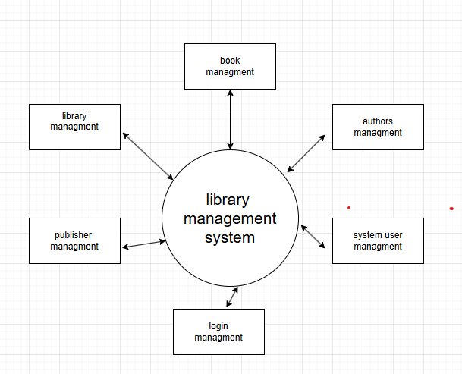

10. Perform a functional analysis for an online shopping system.

Ans.

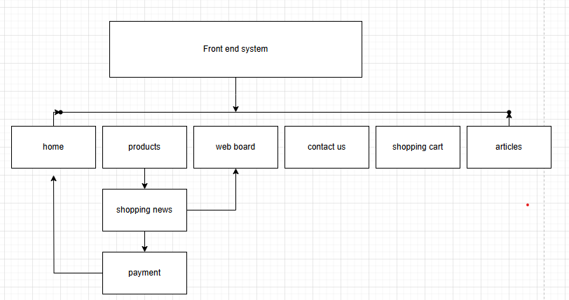

11. : Design a basic system architecture for a food delivery app

Ans.

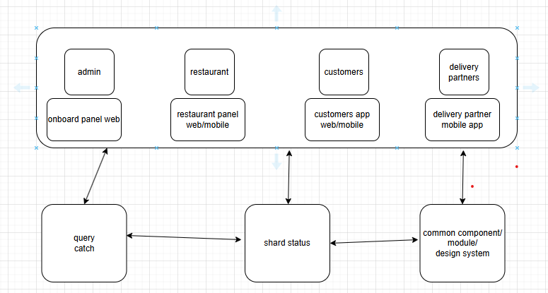

12. Document a real-world case where a software application required critical maintenance.

Ans.

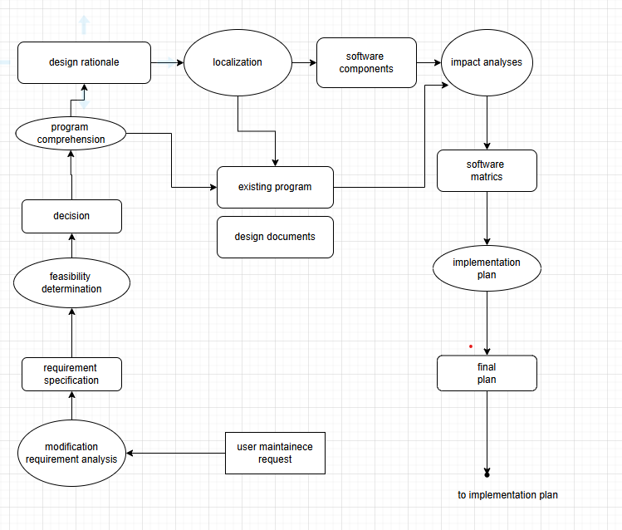

13. Create a DFD for a hospital management system.

Ans.

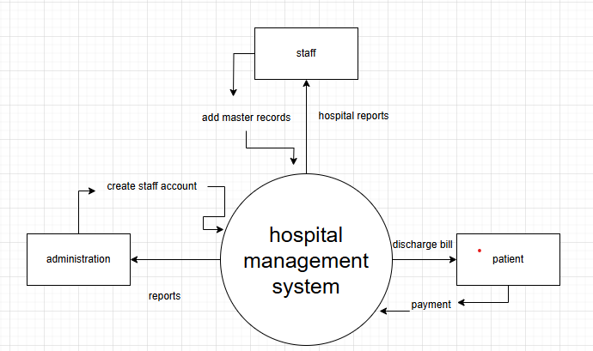

14. Draw a flowchart representing the logic of a basic online registration system.

Ans.

